Team Golf Technical Report
Jackson Fendler, Timothy Long, Rose Wrinkle
ASCI-4050-01: Human Factors
Dr. Gajapriya Tamilselvan
December 2, 2025

Team Golf Technical Report
1,200 runway incursions occur per year, averaging 3 a day-FAA(FAA, 2025a). Runway incursions are very dangerous because they occur during the most critical phases of flight: takeoff, landing, and taxi. Runway incursions can cause serious harm, and we wish to analyze how much of a role a lack of awareness plays in runway incursions and how to improve awareness. Runway incursions are a serious threat to aviation safety. They have continued to occur at a common rate. We have new and improved technology, but they are still occurring often. With improved technology, our situational awareness should improve, and incidents should happen less often. Is there a distraction issue now, or is the technology just not advanced enough? The purpose of this research project is to understand how a lack of situation awareness plays a role in aviation safety. We are focusing on how the lack of awareness causes runway incursion. In the past 10 years, we have made major leaps in technology that are designed to increase situational awareness, yet our yearly runway incursion incidents have remained stagnant. We would like to find out if the technology simply isn’t advanced enough, or if the human element is failing in maintaining awareness. How does lack of awareness contribute to the aviation accident trend of “runway incursions,” and how does technology play a role in improving or impeding situational awareness?
Case Study Background
Case Study #1 - FAA Runway Incursion Severity Chart
Runway incursions are a very serious, dangerous, and a threat to the safety of aviation. The FAA has published an article named Runway Incursions explaining what qualifies as a runway incursion, how it is classified, and the sources of runway incursions. The FAA describes a runway incursion as “Any occurrence… involving incorrect presence of aircraft, vehicle or person on the protected areas … of landing and take off.”(FAA, 2022). This definition alone shows the importance of how any unauthorized access can lead to a huge problem. Airport Runways are often highly dangerous as they involve high-speed aircraft with high-stress situations, and even one runway incursion can create a huge disaster. According to the FAA runway safety data, runway incursions happen over a thousand times per year in the US(FAA, 2025a). Although most of these incidents do not lead to accidents, they still remind us of how a lack of situational awareness in high-stress environments can quickly go from a simple mishap to a major disaster. Lack of awareness and runway incursions continue to be a major human factors issue in aviation.
The FAA has separated the type of runway incurisons into four categories to identify the severity of runway incursions. Category A is the most serious incident, which involves significant potential for collision. Category B is still serious, but with time-sensitive critical corrective and evasive actions, the collision is prevented. Category C describes an incident with ample time or space to prevent a collision. Category D is the baseline of the definition, as anything that is on the space of a runway for takeoff/landing with no clearances, but no immediate safety consequences (FAA, 2022). Why do severity categories matter? Well, these categories help the FAA and its investigators understand an accident and how it was formed. Additionally, by separating the data into categories, we can analyze the trends of runway incursions by severity. This allows us to understand that runway incursions do not often lead to an accident or a close call.
The FAA also distinguishes the sources of these incidents by Operational incidents, pilot deviations, and Vehicle/Pedestrian deviations. Operational incidents are when the incident is the result of an Air traffic controller giving less than the minimum required separation of 2 or more aircraft, or between an aircraft and obstacles, or when clearing an aircraft to take off or land on a closed runway (FAA, 2022). Pilot deviations are when a pilot violates any Federal Aviation Regulation. An example of this can be as simple as a pilot taxis onto the wrong runway or crosses a runway without clearance. Vehicle/Pedestrian Deviations details when Pedestrians or vehicles enter any part of the airport movement areas, like runways or taxiways, without proper authorization from air traffic control (FAA, 2022). Reviewing this, it is clear that pilot deviations are the most relevant form of runway incursions, specifically when pilots deviate from ATC. Pilot deviations mostly come from a failure to maintain situational awareness. The FAA also has a runway incursion severity chart that helps them decide what category to give the runway incursions. These factors include: available reaction time, evasiveness of corrective action, environmental conditions, speed of aircraft and/or vehicle, and proximity of aircraft and/or vehicle (FAA, 2022).
Case Study #2 - FAA Advisory Circular AC 91-73B (Taxi SOPs)
The FAA’s Advisory Circular AC 91-73B emphasizes procedures to reduce runway incursions by improving situational awareness during taxi. Page 5 specifically details expectations for crews to develop and follow standardized operating procedures (SOPs) that minimize confusion and prevent deviations. The AC highlights the importance of maintaining eyes outside the aircraft when taxiing, the risk of overreliance on cockpit technology, the need for proper taxi briefings and route planning, and the use of airport diagrams and clear readbacks (FAA, 2012). The circular acknowledges that lack of situational awareness is a recurring contributor to runway incursions and provides strategies to combat it.
Case Study #3 - NBAA Emerging Airport Technology to Reduce Incursions
Runway incursion remains one of the most persistent hazards to aviation safety, primarily caused by the human factor of a lack of awareness. While the specific number fluctuates slightly, the FAA has cited that multiple occurrences occur every day consistently. This highlights the demand for improved situational awareness both inside and outside of the cockpit. The National Business Aviation Association’s (NBAA) article Emerging Airport Technology Aims to Reduce Runway Incursions (2025) brings light to current innovative projects seeking to reduce runway incursions by improving situational awareness. This provides valuable information to understand how runway incursions occur, cites different approaches to reduce them, and provides hope to further improve aviation safety.
The article begins by citing the frequency of runway incursions and sheds light on the Chicago Midway, Flexjet Southwest runway incursion event. This is one of the events that sparked our interest in runway incursions and the human factor of lack of awareness. It shows how a lapse in awareness can create an extremely dangerous scenario, but on the flip side, a situational aware crew can proactively mitigate risk and perform efficiently. As the article continues, NBAA begins to dive into different technologies aimed at improving runway safety and cites the Federal Aviation Administration’s (FAA) Surface Awareness Initiative (SAI) project.
The FAA’s SAI project was sparked by a multitude of factors, including several high-profile runway incursions during a study of the national airspace system (NBAA, 2025). This project was launched in late 2023 and aimed to create additional situational awareness for tower controllers that lack advanced surface surveillance capabilities (NBAA, 2025). So far, the initiative has been implemented in major airports across the country, such as Nashville, TN; Austin, TX; and Florida’s Miami Executive Airport, providing a surveillance system in addition to traditional radar displays (ASDE-X) that work off of ADS-B data. What separates the existing technology from the new is that the ADSB-based surveillance tool updates within one second, unlike the radar-based one. This project has been handled by SAAB Inc. and will continue to be rolled out across multiple airports across the country (NBAA, 2025). While this technology aims to improve controller situational awareness, it is just one part of the human element involved in aviation.
Another piece of technology being implemented is Universal Taxi Assist by Universal Avionics, aimed at improving situational awareness in the cockpit. The system will listen to radio communication via Bluetooth on an electronic flight bag (EFB), specifically iPads (NBAA, 2025). As EFBs such as iPads become increasingly common in aviation, United Airlines, for instance, provides all of its pilots with iPads. Universal Taxi Assist could provide a practical solution to runway incursions, leveraging pre-existing technology in the cockpit similar to the SAI project (NBAA, 2025). Universal Taxi Assist (UTA) gathers the aircraft-specific information, such as callsign and location, verifies readback, and translates it to text to be displayed on the EFB. The system additionally will translate the conversation in a graphical form where a pilot will “just follow a magenta line as they taxi” (NBAA, 2025). Universal Avionics has plans to integrate its system with third-party systems such as Foreflight. They also have plans to implement the system with augmented reality and artificial intelligence (AI). Instead of looking at the EFB, the magenta line would be displayed via a heads-up display (HUD), as well as provide comprehensive imagery of other aircraft within vision (NBAA, 2025). Universal Avionics believes these technologies can further improve runway safety.
NBAA’s article on Emerging Airport Technology Aims to Reduce Runway Incursions documents current industry efforts to reduce runway incursions, showcasing that it is both a widely recognized problem and that many intend to reduce these occurrences through improving situational awareness. This highlights the importance of examining human factors alongside technological innovations when aiming to fix a problem related to aviation safety. Despite this, we are concerned about further automation in the industry. We know from previous research that humans are poor monitors, and further automation encourages dependency and overreliance. This could lead to a reduction in active listening skills as well as additional restructured training for both pilots and controllers. Of course, time will only tell if these emerging technologies will reduce runway incursions and improve situational awareness.
Case Study #4 - FAA Runway Safety/Runway Incursion Infographic
The FAA’s Runaway Safety infographic provides a comprehensive overview of how runway incursions occur, who is most often involved, and the human factors that commonly contribute to these events (FAA, 2014). The infographic highlights that runway incursions involve pilots, air traffic controllers, and ground vehicles. This reinforces the idea that situational awareness is a shared responsibility across the entire airport environment. It also outlines the four major types of incursions (pilot deviations, operational incidents, vehicle/pedestrian deviations, and others), showing that pilot deviations consistently make up the majority of cases. This aligns with our research findings that loss of situational awareness in the cockpit is a primary contributor to runway incursions, especially during high workload phases like taxi, takeoff, and landing (FAA, 2014).
In addition to defining the types of incursions, the infographic emphasizes key risk factors like confusing airport layouts, misheard or incorrect ATC readbacks, and failure to maintain visual awareness while taxiing. It also presents recommended best practices (like reviewing airport diagrams), which directly target human performance issues linked to situational awareness. By visually summarizing where breakdowns most frequently occur, the FAA infographic reinforces the importance of procedural discipline and strong awareness habits. These points support our overall research by demonstrating that even as technology continues to advance, human attention, planning, and active monitoring remain critical to preventing runway incursions (FAA, 2014).
Databases
We retrieved three databases for our proposed research. First, we utilized the FAA’s data on runway incursions by year. It is separated by the source of runway incursions and provides data from 2016-2025 (FAA, 2025a). Additionally, it allows you to compare one year to another. This data is important because it comes directly from the FAA, so it can be trusted. Secondly, we utilized the Air Charter Safety Foundation's website, which graphically displayed the FAA’s data and assisted us in interpreting. The Air Charter Safety Foundation is a non-profit organization that aims to improve the safety of charter operations. Their data was very helpful because it allowed us to visually compare multiple years at once. This helped us determine that the total runway incursions are remaining relatively stagnant, and pilot deviations remain the most persistent cause (ACSF, 2025). Additionally, they cite the FAA as determining a lack of situational awareness to be a common cause (ACSF, 2025). Lastly, we utilized the FAA's data on runway incursions by category. The data they provide showcases the runway incursions category graphically by table and bar graph. Additionally, it shows how many runway incursions occur for every 1million takeoffs and landings (FAA, 2025b). All of this data together helps us analyze the trend of the rate of occurrence, category, and source of runway incursions across multiple years.
Database #1 - FAA Runway Incursion Statistics https://www.faa.gov/airports/runway_safety/statistics
Database #2 - Air Charter Safety Foundation (ACSF) Summary Graphs https://acsf.aero/safety-spotlight-runway-incursion-prevention/
Figure 1
Graphical illustration of runway occurrence rate and source by year, 2019-2024. Source: ACFS, data: Air Traffic Organization. 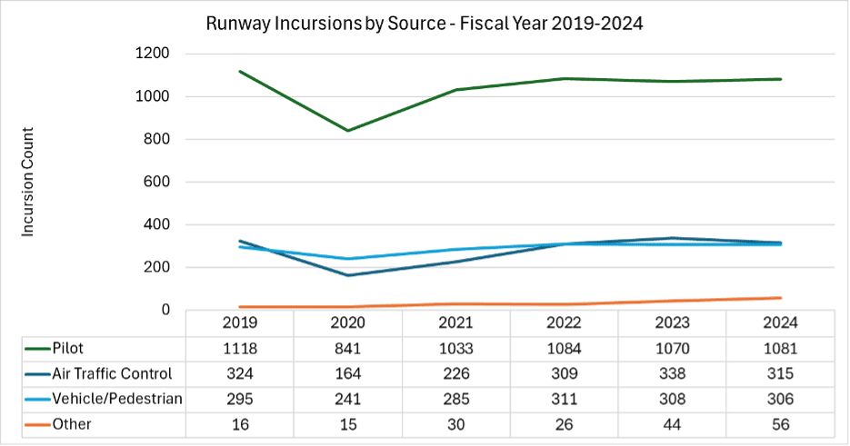
Database #3 - FAA Incursion Severity Categories (A-D) https://www.faa.gov/closecalls
Figure 2
Table chart of runway occurrences by severity category by year, 2014-2024.
Source: FAA, data: Air Traffic Organization.
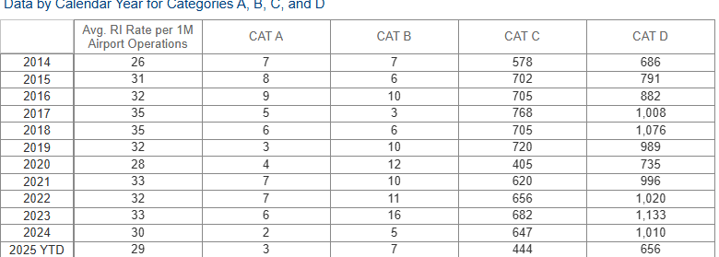
Figure 3
Graphical chart of runway occurrences by severity category by year, 2014-2024.
Source: FAA, data: Air Traffic Organization. 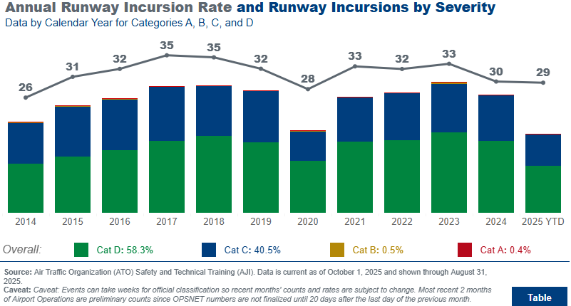
Methodology
Procedure
We retrieved this data by conducting online searches for data on runway incursions through publicly accessible sites. The information we were searching for was already presented in both table and graphical formats. This allowed for easy and straightforward comparisons. The individual data sets were directly linked together on their respective pages, which proves helpful in sourcing the information. Unfortunately, there is no dataset that quantifies the precise number of runway incursions that occurred with a lack of awareness identified as a major contributing factor. Despite this, by reviewing the FAA’s guidance, accident investigation examples, and industry articles, lack of awareness has consistently been identified as a major contributing factor. This suggests that the majority of runway incursions are influenced by the human factor issue of lack of awareness.
When determining how the lack of situational awareness affects runway incursions, we have used multiple archival data from three aviation safety databases: the FAA Runway Incursion Statistic Database. This database includes the annual statistics of runway incursions from 2016-2025, categorized by Pilot deviations, operational incidents, and Vehicle/Pedestrian Deviations (FAA, 2025a). Our group had totaled the yearly runway incursions, allowing us to compare each year side by side, which helped us conclude that runway incursions are stagnant by year.
Next, our graph used the FAA Runway Incursion Category Dataset, which groups runway incursions into categories from A-D based on severity. We had used this dataset to determine if high-risk accidents like Categories A and B incursions have decreased over the years. Reviewing the data and graphics provided, we have seen lower amounts of A and B categorized, but most events still are in Category C and D (FAA, 2022). This information has shown us that while technology and safety have improved, the human factors issue of lack of situational awareness has yet to improve. Additionally, it shows us that while runway incursions are a threat to safety, they have remained minimal threats in terms of the A-D category developed by the FAA.
Our third data set we have is the Air Charter Safety Foundation (ACSF) graphical runway. This dataset helped us view multiple years of FAA runway incursions on the same graph, allowing us to easily compare different years to each other. Using this ACSF chart, we can see that runway incursions have remained stagnant, with no clear increase or decrease (ACSF, 2025). This visual chart helped us solidify our conclusion of stagnant runway incursions.
Results Obtained
Aviation Accident Trend Related to Lack of Awareness
Runway incursion data from 2016-2025 shows that the overall number of incursions has remained consistently stagnant, averaging around 1,100 to 1,300 events per year (FAA, 2025a). Despite technological improvements (such as widespread EFB usage, enhanced taxi diagrams, and more sophisticated cockpit displays), the yearly totals have not shown a meaningful decline. FAA data also indicates that pilot deviations persist as the largest source of incursions every year; these often account for over half of all events (ACSF, 2025). This suggests that the primary issue is not the absence of technology, it’s the human element of situational awareness during high workload phases like taxi, takeoff, and landing.
While categories A and B have decreased slowly over the past decade, Categories C and D continue to dominate the statistics. These lower-severity events still represent lapses in awareness and communication, even though they typically only lead to minor evasive maneuvers and not a collision (FAA, 2022; FAA, 2025b). This consistency over time reinforces the idea that many incursions come from momentary confusion, improper readbacks, distraction, or failure to verify clearances. When combined with the ACSF multi-year runway incursion visualizations, it becomes clear that even though major accidents are rare, the underlying human factors problem of awareness hasn’t improved. This leaves the industry vulnerable to serious incidents when multiple breakdowns layer together.
Accident Case Study - NTSB Event (ATC Lack of Awareness)
Accident Scenario
The selected incident occurred at Austin-Bergstrom International Airport (AUS), where an air traffic controller cleared a departing aircraft for takeoff while another aircraft was on short final to the same runway. According to the NTSB docket, the tower controller did not have surface detection equipment available to assist with monitoring ground traffic, which reduced their situational awareness during a high-activity period (NTSB, 2023). The two aircraft came dangerously close to intersecting paths, making this event a serious runway incursion with high potential for collision. Although no crash occurred, the incident demonstrates how a momentary lapse in awareness at the controller level can create an extremely hazardous situation.
Investigator Information & Analytical Techniques
The NTSB investigated the event using radar data, ATC audio recordings, tower staffing logs, weather observations, and tower equipment capability assessments. Investigators also conducted interviews with the controller on duty, reviewed tower procedures, and examined the lack of ground-surveillance tools that could have alerted the controller to aircraft proximity. Analytical techniques included time-distance calculations, analysis of aircraft approach/takeoff profiles, and reconstruction of controller workload and task saturation leading up to the incursion.

Major Findings

Investigation findings revealed that the air traffic controller misjudged the spacing between the arriving and departing aircraft due to limited visual cues and workload saturation (NTSB, 2023). The NTSB noted that the tower lacked automated surface detection equipment, which would normally assist controllers in identifying runway occupancy. Additionally, radio communication showed no verification that the runway was clear prior to issuing the takeoff clearance, indicating a breakdown in standard ATC procedures. Lighting, visibility, and aircraft performance did not contribute to the event, and pilot actions were consistent with ATC instructions.

Causes of the Accident

The NTSB identified the primary cause was ATC's lack of situational awareness stemming from inadequate monitoring of runway operations (NTSB, 2023). Contributing factors included the absence of surface detection equipment at the AUS tower and high controller workload. These factors collectively led to an incorrect assumption that the runway was clear when it was not (NTSB, 2023). Although pilots followed all instructions correctly, the mismanagement of runway separation created a major runway incursion.

Major Recommendations

The NTSB recommended expanding the installation of surface detection equipment, like ASDE-X or ADS-B-based surface monitoring tools, at airports with moderate or high traffic levels (NTSB, 2023). Additional recommendations included reinforcing ATC training on runway verification procedures, improving staffing during peak periods, and reviewing SOPs for issuing takeoff clearances when arrival traffic is approaching the same runway (NTSB, 2023). The case reinforces the importance of both human situational awareness and technological support systems in preventing runway incursions.
Conclusion
Our research found that runway incursions have remained alarmingly consistent over the last decade, despite major improvements in cockpit technology and airport infrastructure. FAA and ACSF data show that pilot deviations continue to be the most common source of incursions. This indicates that situational awareness in high workload environments is still a major human factor concern. The articles we reviewed show that both pilots and controllers struggle with maintaining awareness, especially when distractions, task saturation, or confusing airport layouts come into play. Our accident case study at Austing-Bergstrom further demonstrated how quickly a lack of awareness can escalate into a high-risk incursion when procedural discipline and technological support are not fully aligned.
To meaningfully reduce runway incursions, the industry must combine technology with improved human-centered strategies. While emerging tools such as surface detection systems and electronic taxi aids show promise, they cannot replace the need for strong training, clear communication, standardized procedures, and intentional attention management. We propose a blended solution that emphasizes enhanced situational awareness training for pilots and controllers, paired with expanding surface monitoring technology at airports that do not currently have it. Ultimately, preventing runway incursions will require a cultural shift that values both technological innovation and the human element equally. By understanding how awareness breaks down and actively trying to strengthen it, the aviation industry can work toward reducing these persistent incidents and improving overall runway safety.
References
Air Charter Safety Foundation. (2025). Runway incursion prevention. ACSF. https://acsf.aero/safety-spotlight-runway-incursion-prevention/
Federal Aviation Administration. (2014). Runway safety. https://www.faa.gov/sites/faa.gov/files/2022-01/Runway%20Safety.pdf
Federal Aviation Administration. (2022). Runway incursions. https://www.faa.gov/airports/runway_safety/resources/runway_incursions
Federal Aviation Administration. (2025). Runway incursion statistics. https://www.faa.gov/airports/runway_safety/statistics
Federal Aviation Administration. (2025). FAA runway safety: Runway incursions by category. https://www.faa.gov/closecalls
Federal Aviation Administration. (2012). Advisory Circular 91-73B: Part 91 and Part 135 single-pilot procedures during taxi operations. https://www.faa.gov/documentLibrary/media/Advisory_Circular/AC_91-73B.pdf
National Business Aviation Association. (2025). Emerging airport technology aims to reduce runway incursions. https://nbaa.org/aircraft-operations/safety/safety-through-innovation/emerging-airport-technology-aims-to-reduce-runway-incursions/
National Transportation Safety Board. (2023). Aviation incident DCA23FA149. NTSB. https://www.ntsb.gov/investigations/Pages/DCA23FA149.aspx

